
Year 9 Mathematics
End of Term 3 Test
Volume, Scientific Notation, Trigonometry and Statistics
Resource Section (Calculators and 1 x A4 (both sides) notes allowed)

Time: 55 mins Name: _______________________________ / 55 marks

Full working out must be shown to get full marks. Attempt all the questions.

Multi-choice Section 5 marks

- The number of goals scored by each team in a round of netball is an example of:

  - Categorical data
  - Discrete Numerical data
  - Skewed data
  - Continuous Numerical data

- The MEAN for the set of data [1, 5, 3, 5, 4, 5, 7, 9] is:

- 5
- 4.875
- 5.571
- 8

- If we add one more 5 to the above set, which is the only measure of central tendency that would change?

- Mode
- Mean
- Range
- Median

- How do we write 6 082 345 in Scientific notation?

- 6.08 x 10⁶
- 6.082345 x 10⁶
- 6.082346 x 10⁶
- 608234.6 x 10⁵

- What would be the capacity of a cube, 10 cm x 10 cm x 10 cm?

- 100 ml
- 1000 ml
- 100 L
- 1000 L

Volume

- Convert the following: 4 marks

  - 2,400,000 cm³ to ____________________ m³ c. 8.3 cm³ to ______________________ mm³

  - 2.8 ML to ___________________________ L d. 0.61 KL to __________________________ L

- Determine the volume of the following prisms and solid: 9 marks (2,2,2,3)

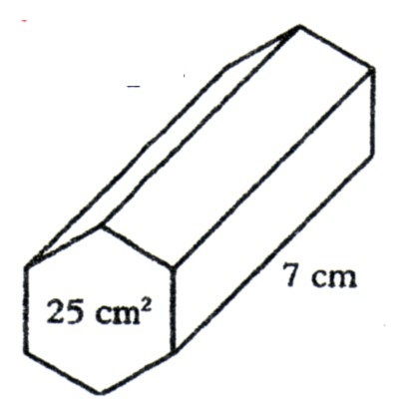 | - 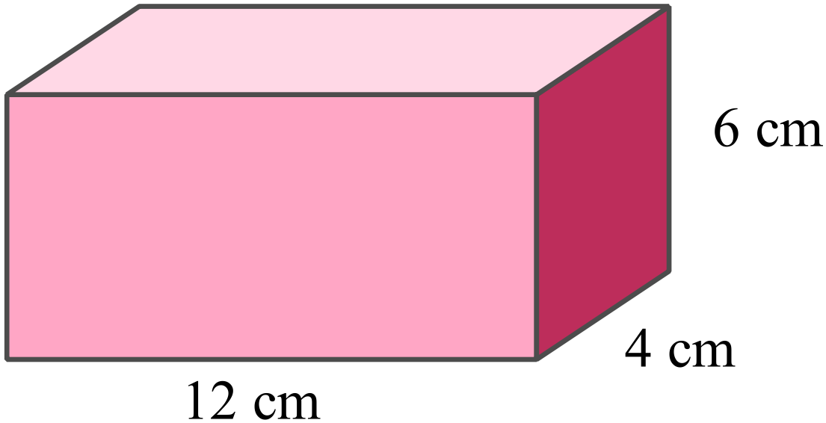

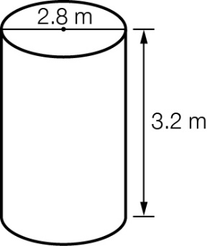
- 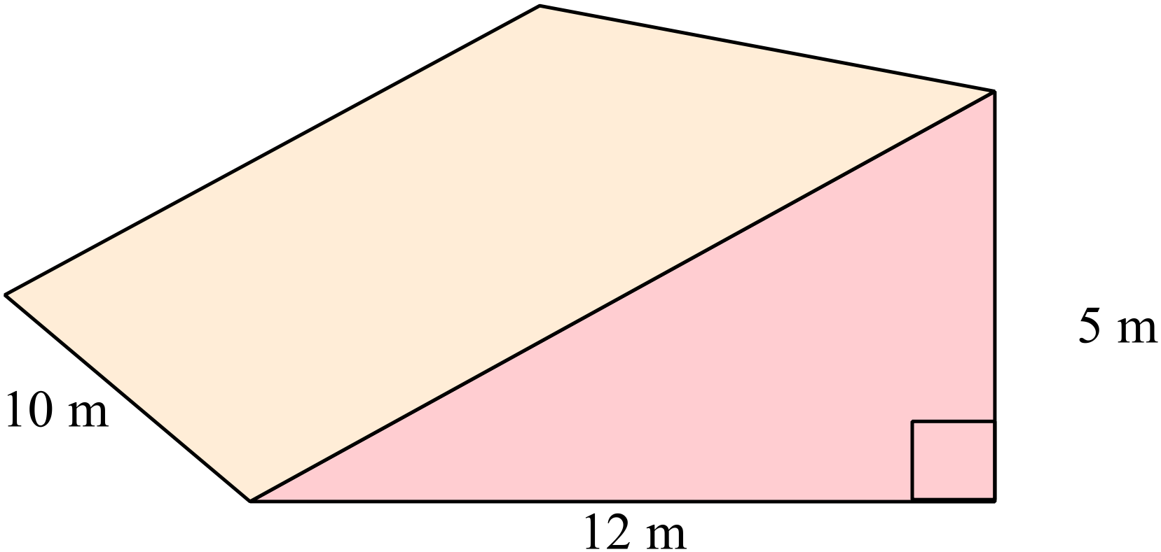 d.

- A water tank has a radius of 165cm and a height of 2.2 m. How much water will the tank hold to the nearest litre? 4 marks

Scientific Notation

- Write the following as numerals: 2 marks

- 3 x 10⁴ = ______________________ b. 7.58 x 10⁻⁵ = ____________________

- Write the following in scientific notation: 2 marks

- 8, 000, 000 = ____________________ b. 0.009802 = _____________________

- Solve the following. Write your answer in scientific notation. 4 marks

a. (6.3 x 10²) (9.8 x 10³) b. The amount of ants that could fit around the equator (in a line) if ants are 8 x 10⁻⁶ km long and the equator is 4 x 10⁴ km long

Statistics

- Frida collected surveyed her class and the class next door and recorded the percentage each person received on their latest maths test. 6 marks

  - Is this an example of primary or secondary data?

  - She presented the data in the graph below. What specifically is this type of graph called?

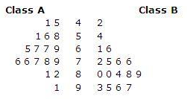

  - She thought the best way to analysis her data was with the median. What is the difference between the medians for the two classes? Show your working.

  - Which class do you think did better in the test and explain your answer by commenting on the shape of the graph for each class?

Trigonometry

- Label the sides (Hypotenuse, Opposite and Adjacent) of the following right angled triangle. 1 mark

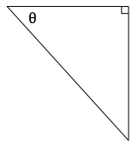

- Label the angle (Ѳ) in the correct place on the following right angled triangle. 1 mark

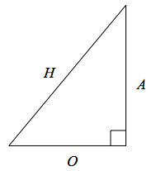

- Calculate the length of x for each of the following right angled triangles to 2 decimal places. 4 marks

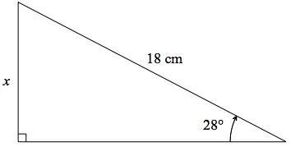 | 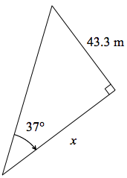

- Find the size of the missing angle in the following right angled triangle to the nearest degree. 2 marks

34m

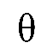

21m

- Amir stands 12.5 m from the base of a building, looking up at the top of the building. If the building is 20m high, what angle is formed by the person’s line of sight and the ground? 3 marks

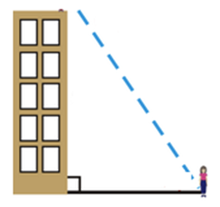

Extension Questions

- A person flying a kite holds the string 1.2 m above level ground, at an angle of elevation of 30°. If the string is 45 m long, what is the height of the kite above ground level.
(Sketch a diagram of the scenario) 4 marks

- Find the volume of the composite solid below 4 marks

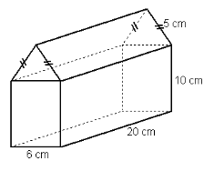

End of Test

